Notification Manager

1- Notification Manager - Ai Question - 1
# Source: AI Source: Provided by: [Data Path: Persons Table -> ID Column: 1, Name_En Column: Motasem Essam] -> From: [ChatGPT] on [6/18/2026]
- Give me project to notify me
- make me can notify different type which each type has title and message and can add sound for notifcation
- make me can notify data and time which can repeat
* once
* every interval
* weekly
* Annualy
- make me can notify battery level to reminve me to plug in or unplug in certain battery level and can repeat to reminder every interval

2- Notification Manager- Ai Answer - 1
# Source: AI Source: Provided by: [Data Path: Persons Table -> ID Column: 1, Name_En Column: Motasem Essam] -> From: [ChatGPT] on [6/18/2026]
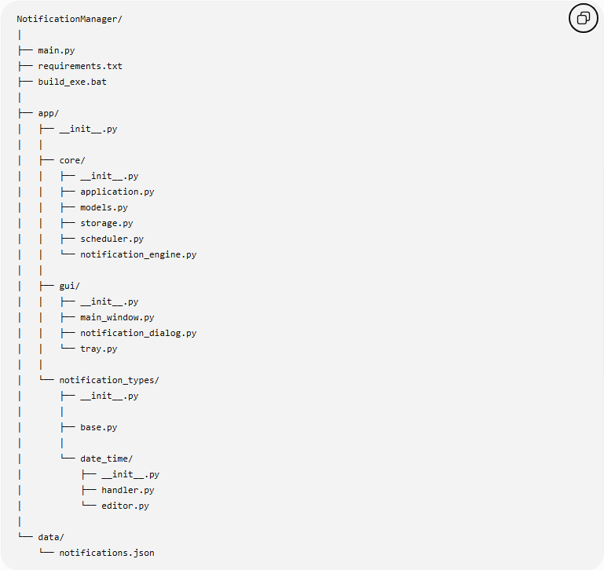
NotificationManager/
│
├── main.py
├── requirements.txt
├── build_exe.bat
│
├── app/
│ ├── __init__.py
│ │
│ ├── core/
│ │ ├── __init__.py
│ │ ├── application.py
│ │ ├── models.py
│ │ ├── storage.py
│ │ ├── scheduler.py
│ │ └── notification_engine.py
│ │
│ ├── gui/
│ │ ├── __init__.py
│ │ ├── main_window.py
│ │ ├── notification_dialog.py
│ │ └── tray.py
│ │
│ └── notification_types/
│ ├── __init__.py
│ │
│ ├── base.py
│ │
│ └── date_time/
│ ├── __init__.py
│ ├── handler.py
│ └── editor.py
│
└── data/
└── notifications.json

